**M4U / WYH CV App scenario wise steps to be followed**

**Scenario 1: Customer is unable to login, view or use services post updating or uninstalling WYH application for PV/CV vehicle.**

Provide Assurance- We will definitely help you on the same by arranging a call back from our WYH team.

Called from registered mobile number-To arrange a call back would like to reconfirm your basic details (Reconfirm from SF)

Called from a non registered mobile number- Probe customer details (Name, Registered mobile number, alternate number, registration number or chasis number)

Thank you for reconfirming your details our WYH application team will call you within 1 working day.

Capture VOC, do the binning and close the call – Query/ WYH app/website/login/registration/login/registration

Note – Immediately inform the TL and arrange a call back.

**Scenario 2: Customer is unable to register/ use the existing WYH application for PV/CV vehicle.**

Provide Assurance- We will definitely help you on the same.

Called from registered mobile number(Reconfirm from SF)- As I can see you have PV/CV vehicle.

Called from a non registered mobile number- Probe customer vehicle

Have you received a pop up message guiding you to download the M4U (If PV) WYH CV (CV) application?

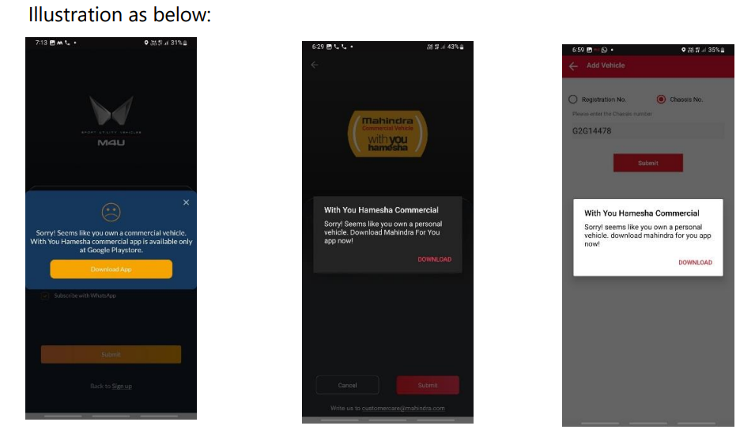

If Yes/No:

PV – Request you to update your existing WYH application. After updating, it will become the Mahindra For You app. Please log in with your registered mobile number to continue using it

CV- Request you to uninstall the existing With You Hamesha app and download the new With You Hamesha Commercial app from the Google Play store

Do the binning and close the call – Query/ WYH app/website/login/registration/login/registration

**Scenario 3: What all services are available in the M4U app.**

Provide Assurance- We will definitely help you on the same.

The Mahindra For You app is a new application designed for both existing and new owners of Mahindra passenger vehicles. It offers various features for vehicle ownership management.

Post booking features: Booking management, vehicle delivery, KYC documents upload Post delivery features: Service booking & maintenance, Roadside assistance, Test drive booking

**Scenario 4: Want to update contact number/ Details update.**

Provide Assurance- We will definitely help you on the same.

Called from registered mobile number(Reconfirm from SF)- As I can see you have PV/CV vehicle.

Called from a non registered mobile number- Probe customer vehicle

Guide Service manager number.

Do the binning and close the call – Query/ Service Query/ Dealer Location/Contact Details/ Dealer Location/Contact Details

**Scenario 5: Want to update KYC**

Provide Assurance- We will definitely help you on the same.

Called from registered mobile number(Reconfirm from SF)- As I can see you have PV/CV vehicle.

Called from a non registered mobile number- Probe customer vehicle

Guide Sales manager number.

Do the binning and close the call – Query/ Sales Query/ Dealer Location/Contact Details/ Dealer Location/Contact Details